RATE |  | 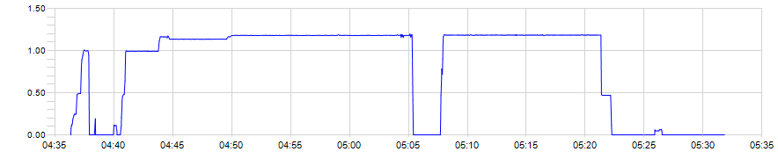
 |  | ■ 445060 Rate Total
PRESSURE |  | 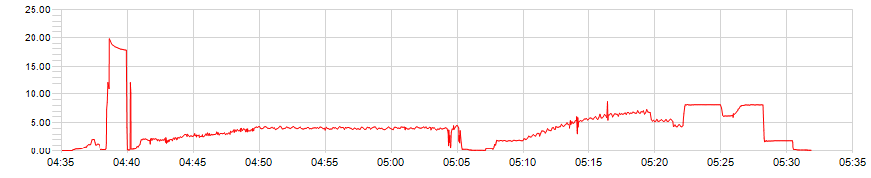
 |  | ■ 445060 Pump Pressure
DENSITY |  | 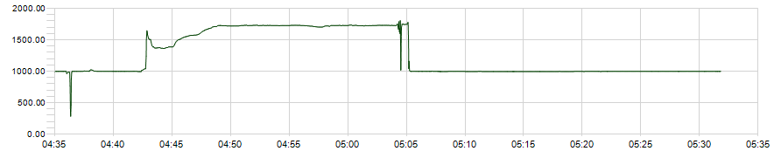
 |  | ■ 445060 Density

